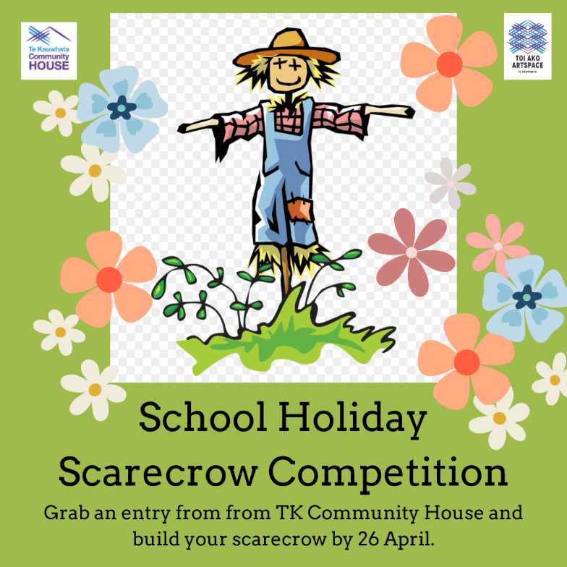
Terms of Conditions &
Entry Form

Gather natural, recycled and second hand goods to design and assemble a scarecrow to adorn the front fence of the community garden. We're looking for friendly creations that scare birds but not people. You can work as a family, individual or group of friends. There will be three prizes given to:
- Most Creative Design
- Cleverest Construction
- Gardener's Choice
Scarecrows must be delivered to the Te Kauwhata Community Garden between 10 - 11am on Friday 26 April, or previously by arrangement.
In the event of rain we will notify you of a change of drop off location to the Toi Ako Artspace. The scarecrows will be displayed indefinitely at the garden for the community to enjoy. Please note it will be outdoors and in the weather. We take no responsibility for any damage that may come to your scarecrow while on display.
We will notify you when you may return and take your scarecrow home.

In order to enter the competition please return this form to Te Kauwhata Community House or emails us at artstekauwhata@gmail.com.

When you bring in your completed scarecrow we will also ask you to advise the names and ages of everyone in your team and a name for your scarecrow.

SCARECROW COMPETITION ENTRY
Contact Name:
Email:
Phone:

